**TO SUPPLY LEFTOVER FOOD TO POOR**

**COLLEGE NAME:** SRI KRISHNA ADITHYA COLLEGE OF ARTS AND SCIENCE

**COLLEGE CODE:** asbruag

**TEAM ID:** NM2025TMID22218

**TEAM MEMBERS:**

**Team leader name:** ADITHYA PRADEEP

**Email:** 23bsai104adithyapradeep@skacas.ac.in

**Team member 1:**KOUSHIKA M R

**Email:** 23bsai123koushikamr@skacas.ac.in

**Team member 2:**MADHU SRI S

**Email:** 23bsai127madhusris@skacas.ac.in

**Team member 3:**SWATHI S

**Email:**23bsai160swathis@skacas.ac.in

**1.INTRODUCTION**

**PROJECT OVERVIEW:**

The “**To Supply Leftover Food To Poor”** project is a Salesforce-based application designed to streamline the process of collecting, managing, and distributing surplus food to the needy. By leveraging Salesforce automation tools such as flows, approval processes, and triggers, the project ensures efficiency, transparency, and accountability in food distribution.

**PURPOSE:**

The main objective of the project is to enable organizations, NGOs, and volunteers to efficiently collect surplus food from donors and distribute it to recipients in need. It reduces manual errors, improves tracking, and ensures timely food delivery.

**DEVELOPMENT PHASE**

**CREATING A DEVELOPER ACCOUNT:**

**By using this url:** [**https://developer.salesforce.com/signup**](https://developer.salesforce.com/signup)

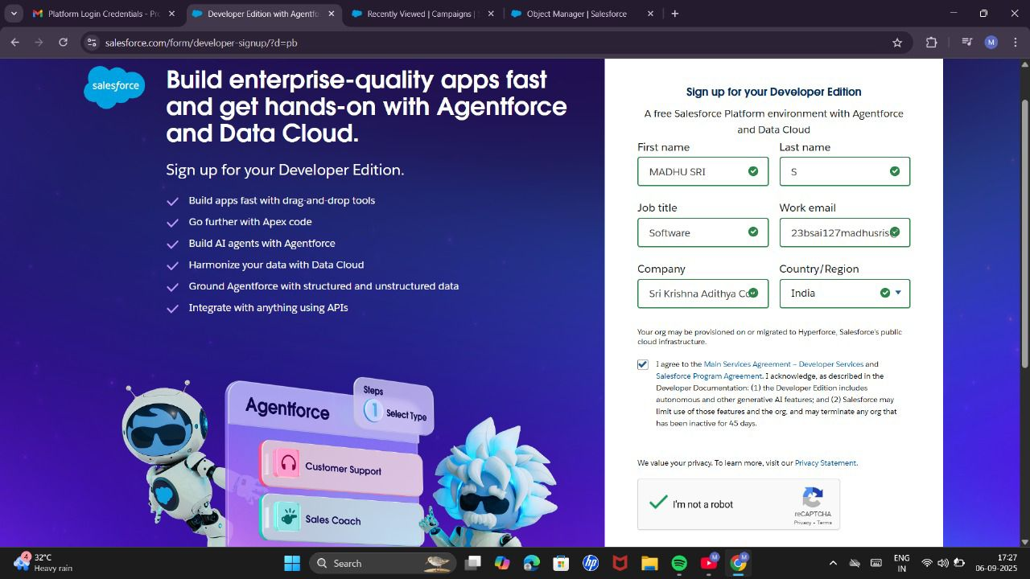

**OBJECT CREATION:**

VENUE :

DROP-OF POINTS:

TASK:

VOLUNTEER:

EXECUTION DETAILS:

**CREATING CUSTOM TABS FOR ALL OBJECTS:**

**CREATING A LIGHTNING APP:**

**CREATING FIELDS:**

FIELDS FOR VENUE OBJECT:

FIELDS FOR DROP-OF POINTS OBJECT:

FIELDS FOR TASK OBJECT:

FIELDS FOR VOLUNTEER OBJECT:

FIELDS FOR EXECUTION DETAILS:

**CREATING FLOWS:**

**CREATING TRIGGER:**

**PROFILE:**

**CREATION OF USERS:**

**CREATION OF USER 1:**

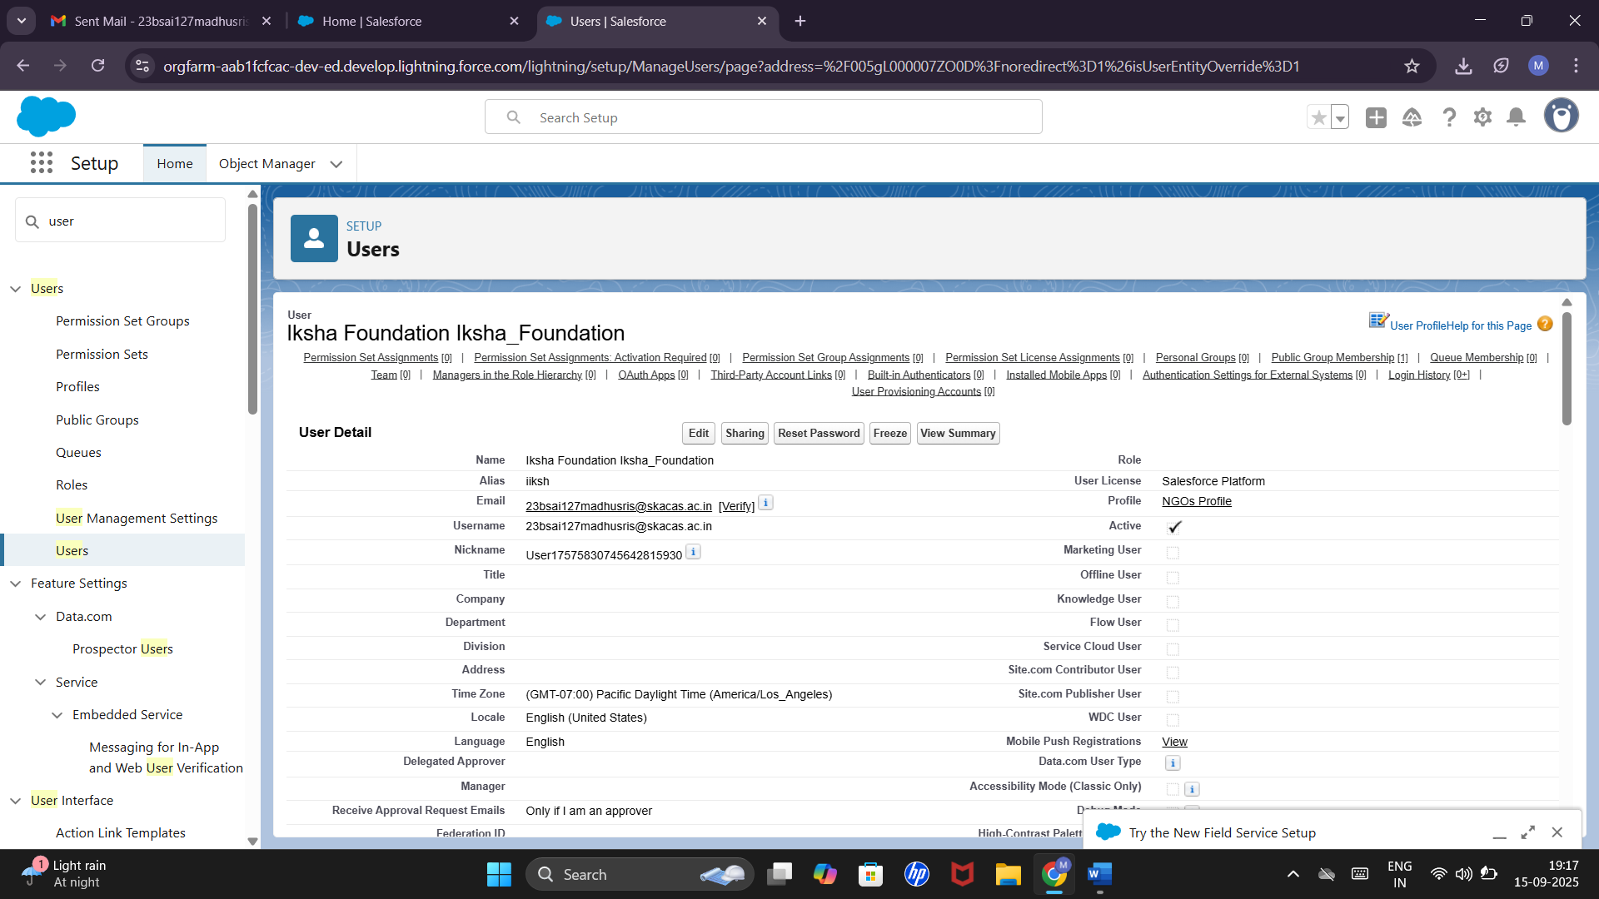

**CREATION OF USER 2:**

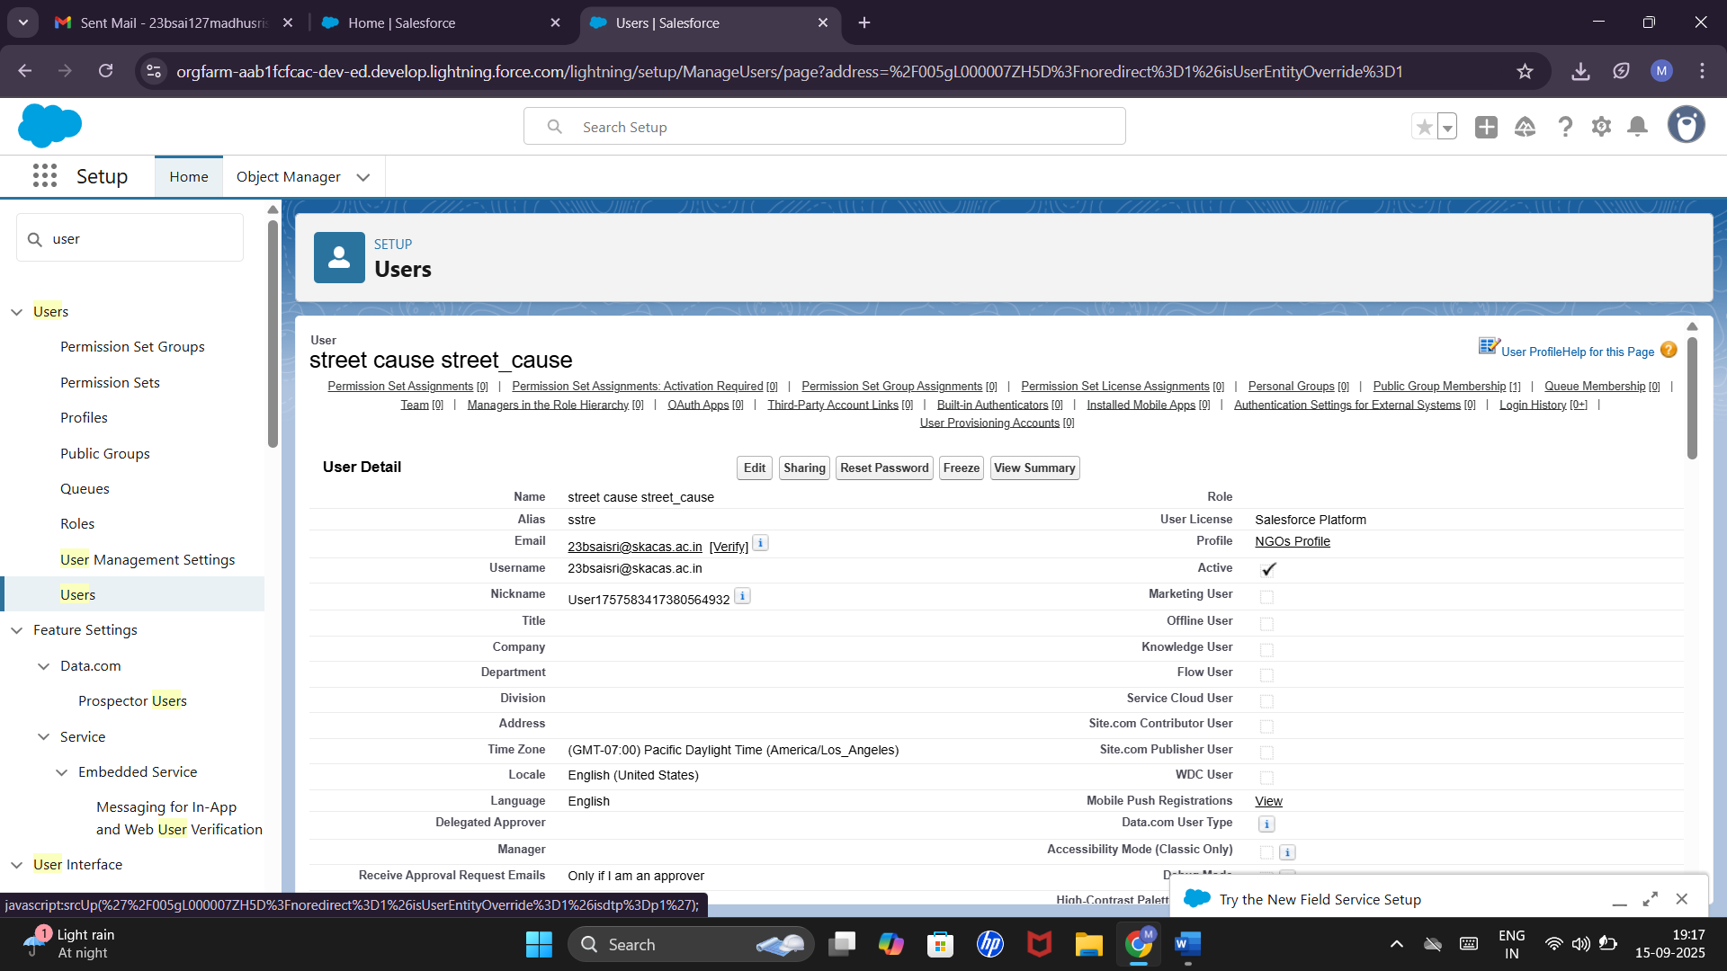

**CREATION OF USER 3:**



**CREATION OF PUBLIC GROUPS:**

**GROUP 1:**

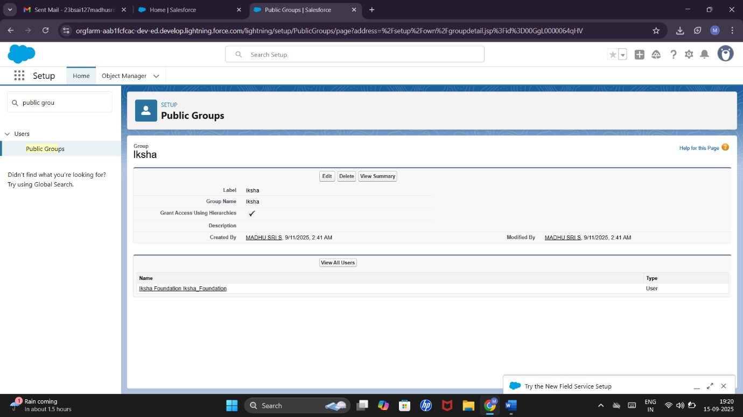

**GROUP 2:**

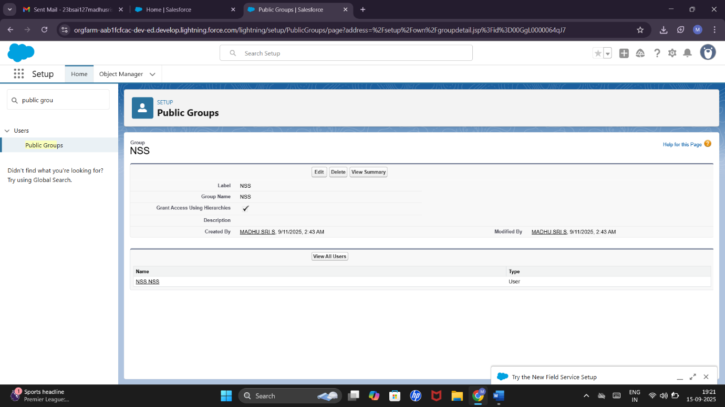

**GROUP 3:**

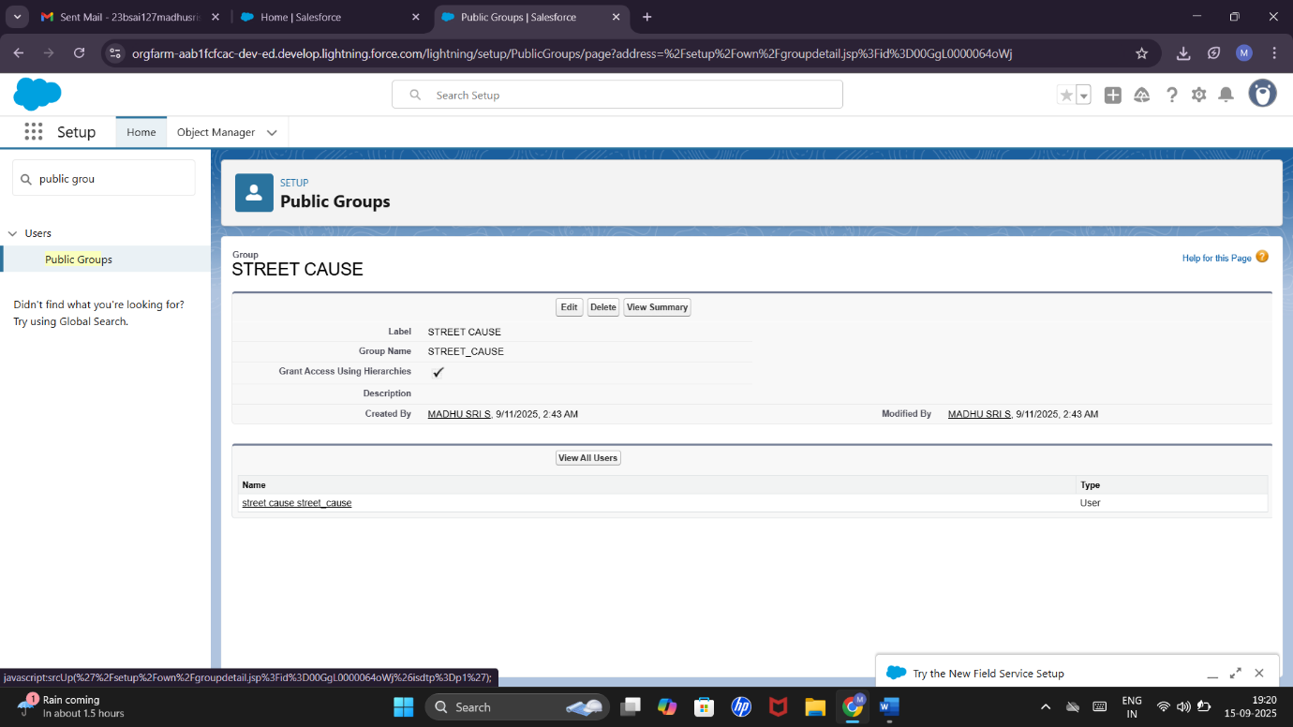

**CREATION OF REPORT TYPES:**

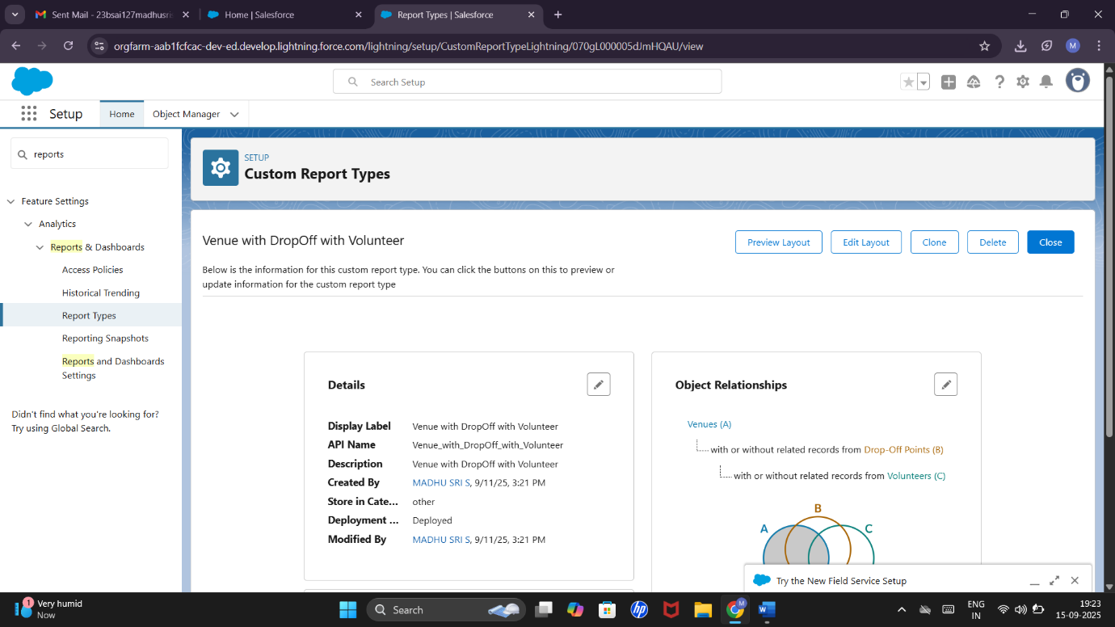

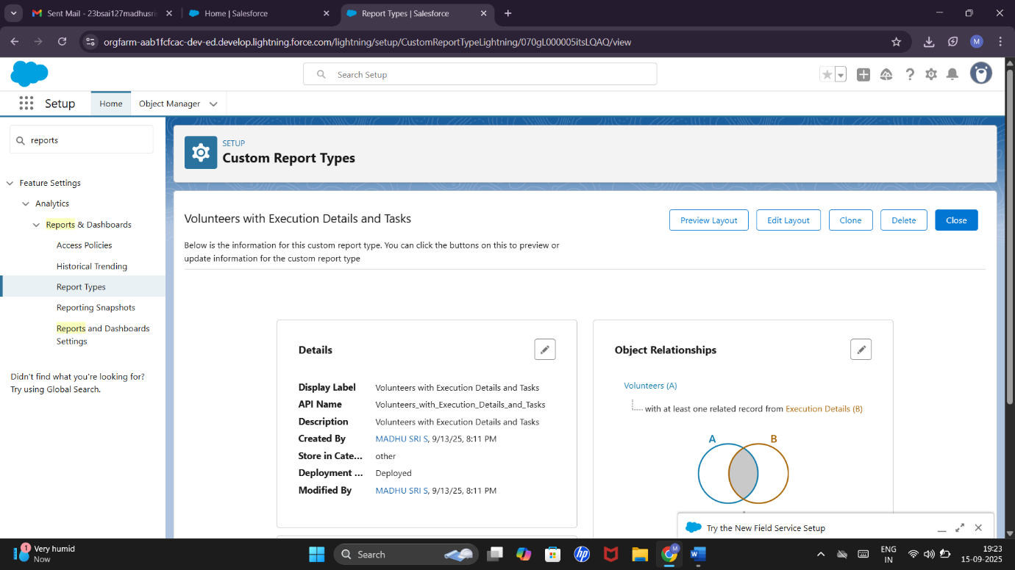

**REPORTS:**

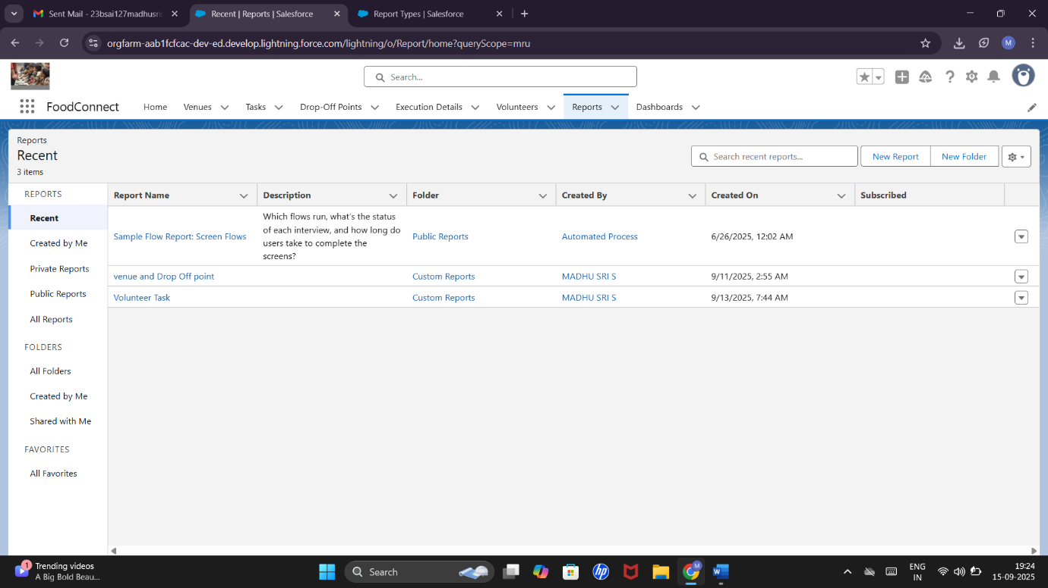

**CREATION OF REPORT ON VENUE WITH DROP-OFF WITH VOLUNTEER:**

**CREATION OF REPORTS ON VOLUNTEER WITH EXECUTION DETAILS AND TASKS:**

**CREATION OF DASHBOARDS:**

* ADDING VENUE AND DROP OFF POINT REPORT TO THE DASHBOARD
* ADDING VOLNTEER TASK REPORT TO THE DASHBOARD
* ADDING A PICTURE TO THE DASHBOARD

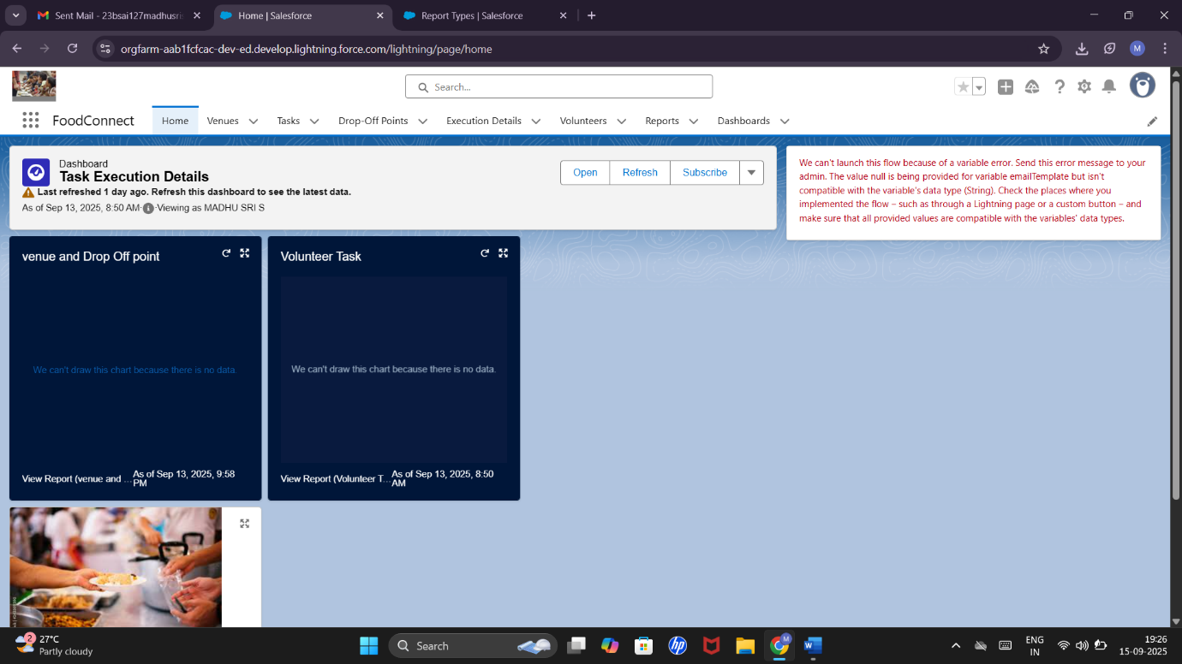

**CREATION OF SHARING RULES:**

**RULE 1:**

**RULE 2:**

**RULE 3:**

**CREATION OF HOME PAGE:**



**ADVANTAGES & DISADVANTAGES**

**Advantages:**

* Efficient management of surplus food.
* Transparency in distribution.
* Automated reminders reduce delays.
* Easy tracking of donors and recipients.

**Disadvantages:**

* Dependent on internet and Salesforce platform.
* Requires user training for effective use.

**CONCLUSION**

The To Supply Leftover Food To Poor Salesforce application successfully streamlines food collection and distribution. It improves efficiency, communication, and transparency, ensuring surplus food reaches the needy on time.

**APPENDIX**

**Trigger Code :**

trigger DropOffTrigger on Drop_Off_point__c (before insert) {

for(Drop_Off_point__c Drop : Trigger.new){

Drop.Distance__c = Drop.distance_calculation__c;

}

}